PWM_TASK program:

1. For 20% duty cycle.

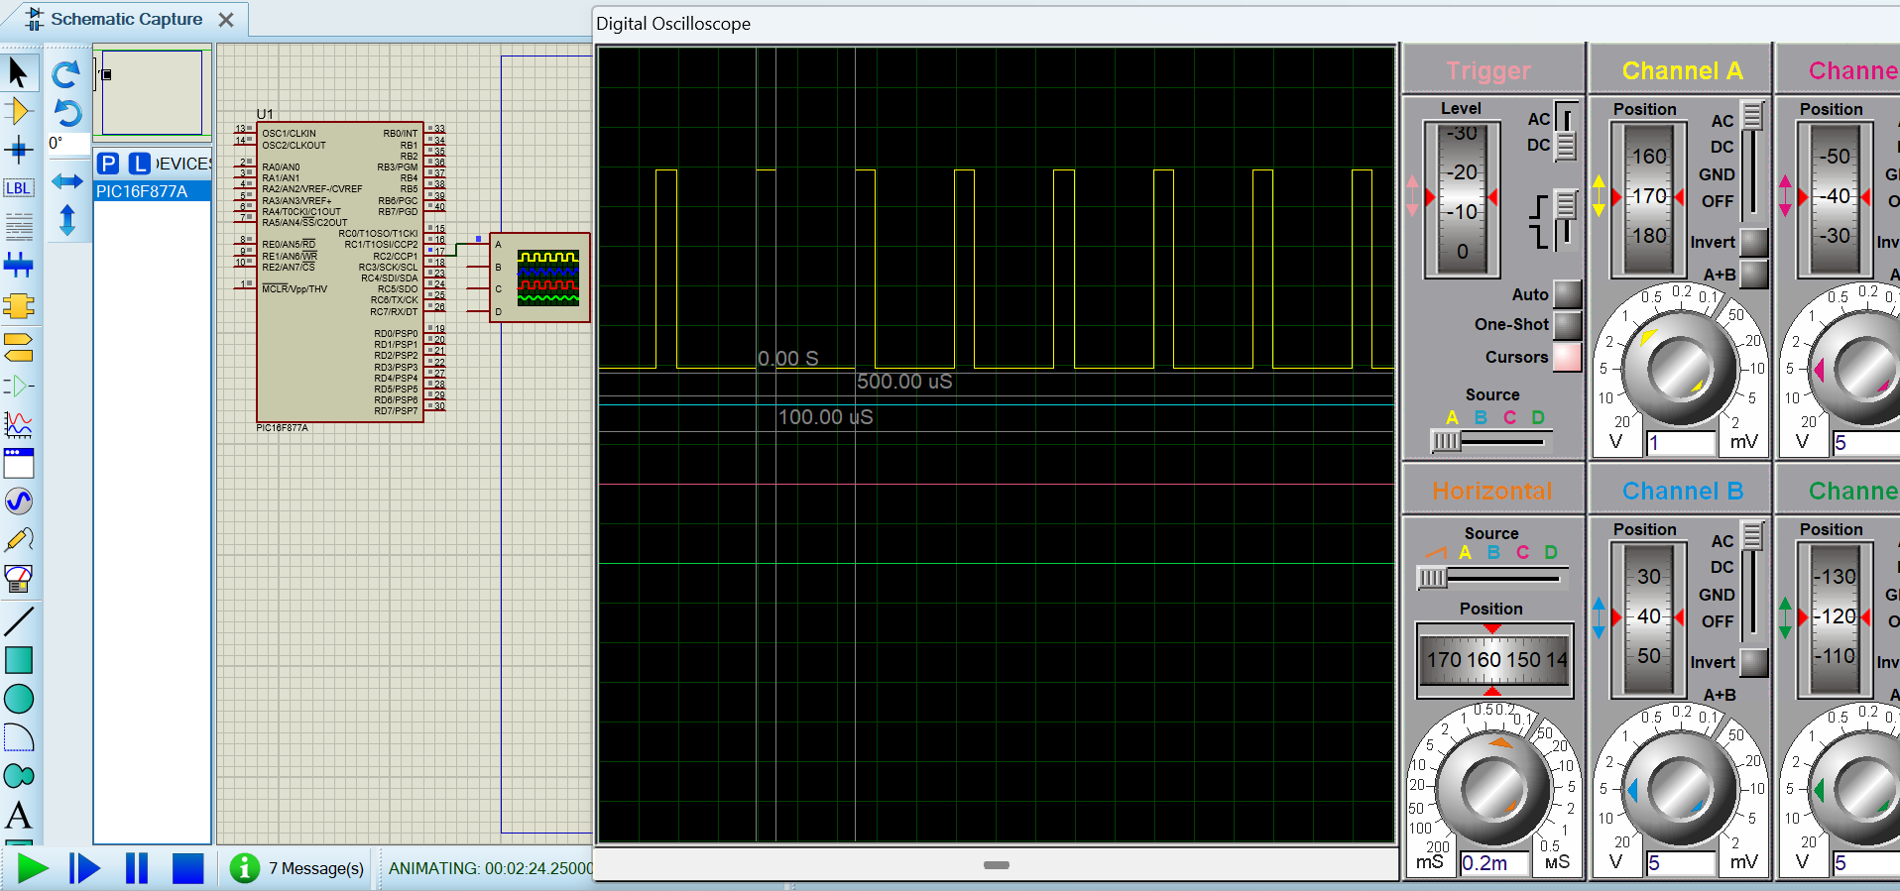

1. For 60% duty cycle.

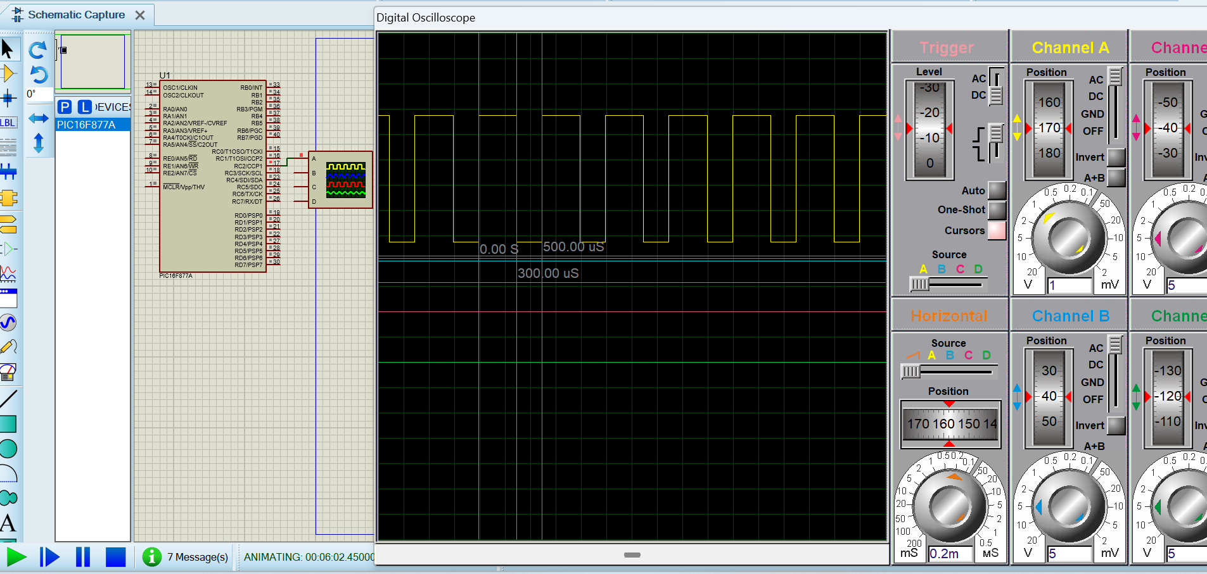

1. For 90% duty cycle.

